**OFFICE MANAGEMENT SYSTEM**

A COURSE PROJECT REPORT

By

**SISTU ALEKHYA(RA2011003010388)**

**GINNELA JAYADEEP(RA2011003010397)**

**ADITYA DEY(RA2011003010406)**

**YEDDULA BHARATH SIMHA(RA2011003010407)**

Under the guidance of   
**JAGADEESAN. S***In partial fulfilment for the Course*

of

18CSC302J - COMPUTER NETWORKS

in CSE – F1



**FACULTY OF ENGINEERING AND TECHNOLOGY SRM INSTITUTE OF SCIENCE AND TECHNOLOGY**

**Kattankulathur, Chenpalpattu District**

NOVEMBER 2022

**SRM INSTITUTE OF SCIENCE AND TECHNOLOGY**

**(Under Section 3 of UGC Act, 1956)**

**BONAFIDE CERTIFICATE**

Certified that this mini project report "**OFFICE MANAGEMENT SYSTEM** " is the bonafide work of **SISTU ALEKHYA(RA2011003010388),GINNELA JAYADEEP(RA2011003010397),** **ADITYA DEY(RA2011003010406),** **YEDDULA BHARATH SIMHA(RA2011003010407)** who carried out the project work under my supervision.

# SIGNATURE

JAGADEESAN S

# FACULTY ADVISOR

CSE – F1

SRM Institute of Science and Technology

# ABSTRACT

# Office management helps to maintain a close relationship between the different departments and people.

# Office management helps in transmission of networks between various departments in an office using minimal amount of routers

# Admin can track all the information of Time Entries, Resources, Offices etc.

# Office Management refers to the entire process and procedure of managing office documents from all the departments. Be it the customer feedback or financial statements, documenting all of these in order to maintain their records for professional purposes of the company is known as office management. There are numerous ways of managing documentation, from maintaining hard copies to saving scanned files or opting for software assistance.

# Office Management is a major constituent in the functioning of every enterprise. It includes all aspects like planning, documentation, coordination and maintenance of office records and employees.

# Depending upon the kind of enterprise, there are different types of office management system.

# The basic idea behind managing an office is to ensure that there is proper control over every element of the work space in order to enhance the proficiency and productivity of the organization.

# In this project we have used CISCO packet tracer in which (5) attributes and connected them with (3) routers (5) switches and connected them together so that the transmission and sharing of data is simple.

# ACKNOWLEDGEMENT

We express our heartfelt thanks to our honorable **Vice Chancellor Dr. C. MUTHAMIZHCHELVAN**, for being the beacon in all our endeavors.

We would like to express my warmth of gratitude to our **Registrar Dr. S. Ponnusamy,** for his encouragement

We express our profound gratitude to our **Dean (College of Engineering and Technology) Dr. T. V.Gopal,** for bringing out novelty in all executions.

We would like to express my heartfelt thanks to Chairperson, School of Computing **Dr. Revathi Venkataraman,** for imparting confidence to complete my course project

We wish to express my sincere thanks to **Course Audit Professor Dr.Annapurani Panaiyappan, Professor and Head, Department of Networking and Communications** and **Course Coordinators** for their constant encouragement and support.

We are highly thankful to our my Course project Faculty <**Faculty Name>, <Designation>, <Department>,** for his/herassistance, timely suggestion and guidance throughout the duration of this course project.

We extend my gratitude to our **HoD <Name> <Designation>, <Department>** and my Departmental colleagues for their Support.

Finally, we thank our parents and friends near and dear ones who directly and indirectly contributed to the successful completion of our project. Above all, I thank the almighty for showering his blessings on me to complete my Course project.

**TABLE OF CONTENTS**

## CHAPTERS CONTENTS PAGE NO.

* + - 1. **ABSTRACT**
      2. **INTRODUCTION**
      3. **REQUIREMENT ANALYSIS**
      4. **ARCHITECTURE & DESIGN**
      5. **IMPLEMENTATION**
      6. **EXPERIMENT RESULTS & ANALYSIS**
         1. RESULTS
         2. RESULT ANALYSIS
      7. **CONCLUSION & FUTURE ENHANCEMENT**
      8. **REFERENCES**

1. **INTRODUCTION**
   1. **Scenario Description**

**Office Management** refers to the entire process and procedure of managing office documents from all the departments. Be it the customer feedback or financial statements, documenting all of these in order to maintain their records for professional purposes of the company is known as office management. There are numerous ways of managing documentation, from maintaining hard copies to saving scanned files or opting for software assistance.

Initially, **Office Management** was a manual system of maintaining hard copy paper records of Information and documents. But with time, this conventional method got replaced with a software system that maintains a library for all office-related documents and helps in paperless and convenient office management. This software is known as an **Office Management System.**

This software assorts all documentation on a cloud-based interface. It stores, protects and manages all the documents along with providing convenient access through security credentials.

1. **REQUIREMENTS** 
   1. **Requirement Analysis**

From the given scenario, we draw the following requirements:

1. Identifying the appropriate hardware which would be used (Cisco Packet Tracer)

2. Users on the internet should be able to access only https on the e-commerce server.

3. Users on the internet should have access only to the public IP address of the server and not the private IP address.

4. The users in the organization should have full access to the server.

5. TCP/IP Network design with IP addressing

6. Features and configuration required on the hardware with explanation

We need to configure a network design keeping the following requirements in mind.

* 1. **Hardware Requirement**

From the given scenario, we draw the following requirements:

3 Routers

End Devices

5 x Switches

1 x Marketing

1 x Management

1 x HR

1 x Accounts

1 x Server Switch

Per each Switch

4 x End Devices

For connection of Routers:

Serial DCE is used.

Protocol Used to establish connection:

ARP protocol

**ARCHITECTURE AND DESIGN**

* 1. **Network Architecture**

The network architecture is as follows:

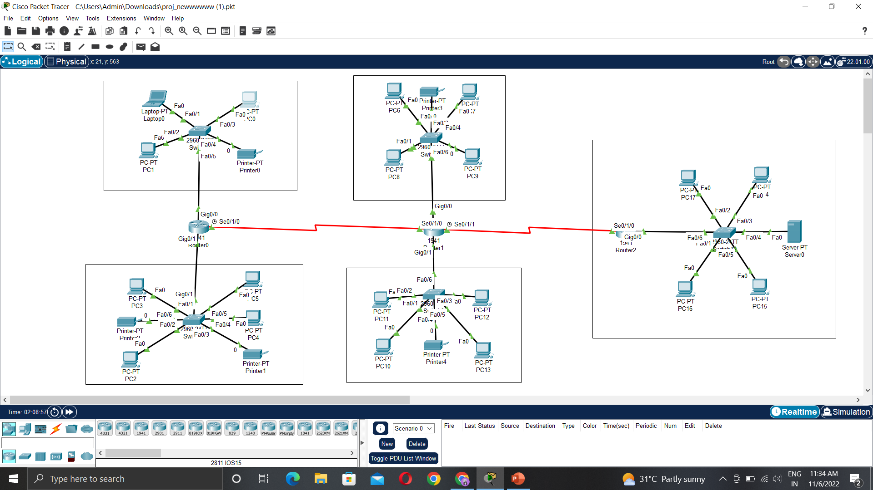

The architecture consists of Five major networks:

* 5 Switches
* 3 Routers
* Network maintained by the Internet Service Provider

These networks are interconnected with each other with varying degrees (discussed in the implementation chapter).

1. **IMPLEMENTATION**
   1. **Address Table**

|  |  |  |
| --- | --- | --- |
| **Devices** | **Interface** | **Address** |
| Router 0 | |  | | --- | | Gigabit Ethernet 0/0 | | Gigabit Ethernet 0/1 | | Serial 0/1/0 | | |  | | --- | | 192.168.10.1 | | 192.168.20.1 | | 192.168.60.1 | |
| Router 1 | |  | | --- | | Gigabit Ethernet 0/0 | | Gigabit Ethernet 0/1 | | Serial 0/1/0 | | |  | | --- | | 192.168.30.1 | | 192.168.40.1 | | 192.168.60.2 | |
| Router 2 | |  | | --- | | Gigabit Ethernet 0/0 | | Serial 0/1/0 | | |  | | --- | | 192.168.50.1 | | 192.168.70.2 | |

The Company Router has NAT configured with an ACL.

The Access Control List contains the entire broadband network. Any request from that network is translated to the private IP of the server.

Static Routing is used on all the routers to interconnect the networks.

1. **RESULTS AND DISCUSSION**
   1. **Connection Check**

The network connections were checked by ping requests:

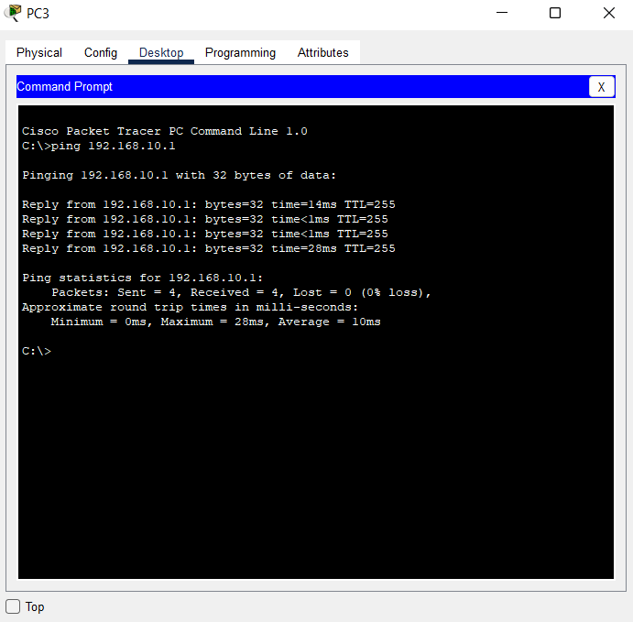

A public PC pinging the server via public IP

* 1. **HTTPS Check**

The server access was checked with HTTPS by using a browser:

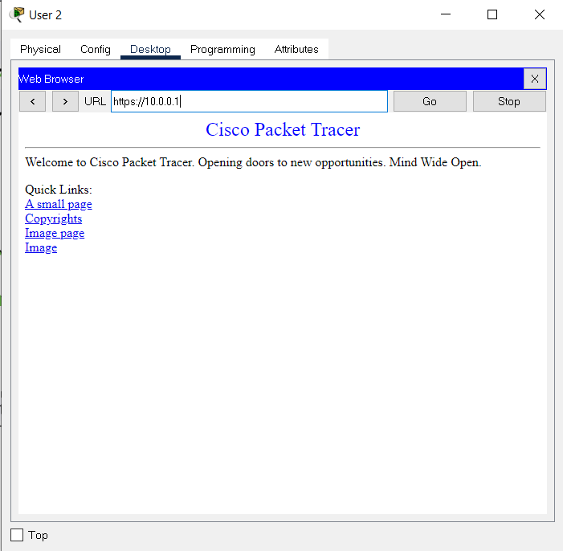

1. **CONCLUSION AND FUTURE ENHANCEMENT**

**Conclusion:**

Office Management refers to the entire process and procedure of managing office documents from all the departments. Be it the customer feedback or financial statements, documenting all of these in order to maintain their records for professional purposes of the company is known as office management. There are numerous ways of managing documentation, from maintaining hard copies to saving scanned files or opting for software assistance.

**Future Enhancement:**

It helps for expansion and diversification. Management provides leadership by influencing and guiding office personnel. Managers influence his subordinates to work willingly for achieving organizational goals.

The basic idea behind managing an office is to ensure that there is proper control over every element of the work space in order to enhance the proficiency and productivity of the organization.

**REFERENCE**

[**https://packet-tracer.en.softonic.com/**](https://packet-tracer.en.softonic.com/)

[**https://juntrax.com/blog/office-management-system/**](https://juntrax.com/blog/office-management-system/)

[**https://www.geeksforgeeks.org/what-is-cisco-packet-tracer/#:~:text=The%20main%20purpose%20of%20Cisco,the%20hardware%20Routers%20or%20Switches**](https://www.geeksforgeeks.org/what-is-cisco-packet-tracer/#:~:text=The%20main%20purpose%20of%20Cisco,the%20hardware%20Routers%20or%20Switches)**.**

**Stewart, R. (1967). Managers and Their Jobs. London: Macmillan.**